
ELEVATED CORE HEALTH
Intake, Verification & Front-Desk Automation — Developer Build Brief
Prepared for the ECH development team | Version 1.0
Purpose of this document
This brief consolidates every automation discussed for Elevated Core Health's patient intake and lead-generation pipeline into a single build spec. It covers: (1) automated intake capture from booking platforms and phone calls, (2) automated verification of benefits (VOB), (3) the exception-routing logic that keeps human staff (Jude) touching only what actually needs a human, (4) a plain-language explainer of Make.com for anyone on the build team unfamiliar with the tool, (5) a website chatbot for lead capture with live handoff, and (6) a lightweight CRM to track leads before they become patients. This is a build spec, not a finished technical design — flagged open questions need vendor/API confirmation before implementation.

1. Current Stack & System of Record
Before building anything new, here is what already exists and what each system's role is:
System | Role
Optimantra | EHR of record. Patient charts, scheduling, telehealth, patient portal, and native integration with Eligible (insurance eligibility/VOB vendor).
MedWriter | AI dictation tool. Generates clinical notes; pushes into Optimantra (known bug: line breaks strip on push — flag for vendor).
Make.com | No-code automation/integration layer. See Section 5 for a full explainer.
ClickUp / Care Pipeline Portal | Internal patient-status tracking (7-stage Kanban: Onboarding → Reconciled). Portal is spec'd but not yet live with a backend/webhook.
Headway, Grow Therapy, ZocDoc, Klarity | Patient acquisition / booking platforms. Source of inbound bookings that should trigger intake automation.
Refixed | Billing team — handles insurance billing and Headway/Grow Therapy data entry.
Scribe Align | Provides a VA for daily charting support (with backup coverage) and runs an ongoing clawback/documentation chart audit before submission.
Jude | Front-desk/intake contractor (AM shift). Should only be looped in for exceptions once this automation is live — not for routine data entry.

2. Target End-to-End Flow
The goal: a patient books (online or by phone) and everything through eligibility verification happens with zero manual touch, unless something is actually wrong.
- Trigger — most bookings arrive by email or text notification from Headway, Grow Therapy, ZocDoc, Klarity, or Google — this is the primary, high-volume channel. Direct phone calls happen too, but are the minority channel (see Section 7).
- Capture — booking/call data is parsed and a patient card is auto-created in the Care Pipeline / ClickUp board at the ONBOARDING stage.
- Forms — demographics, insurance, HIPAA Notice of Privacy Practices, informed consent, telehealth consent, and PHQ-9/GAD-7 are auto-sent via the Optimantra patient portal immediately on card creation.
- Profile push — captured demographic + insurance data is written into the matching Optimantra patient profile fields.
- Auto-VOB — Optimantra's existing Eligible integration runs off that profile data and writes eligibility/benefit results back into the chart. (See Section 4 — one detail needs confirming with Optimantra support.)
- Routing — if forms are complete and eligibility is confirmed, the card auto-advances to SCHEDULED/READY. If something is missing or eligibility fails, the card is flagged for Jude — this should be the only point a human is looped in.
- Reminders — automated appointment reminder sequence (text/email) runs from card creation through visit day. A stale-card flag alerts Jude if a card sits with no activity past a defined threshold.
- Visit day — Donna sees the patient with forms, insurance verification, and chart prep already complete.
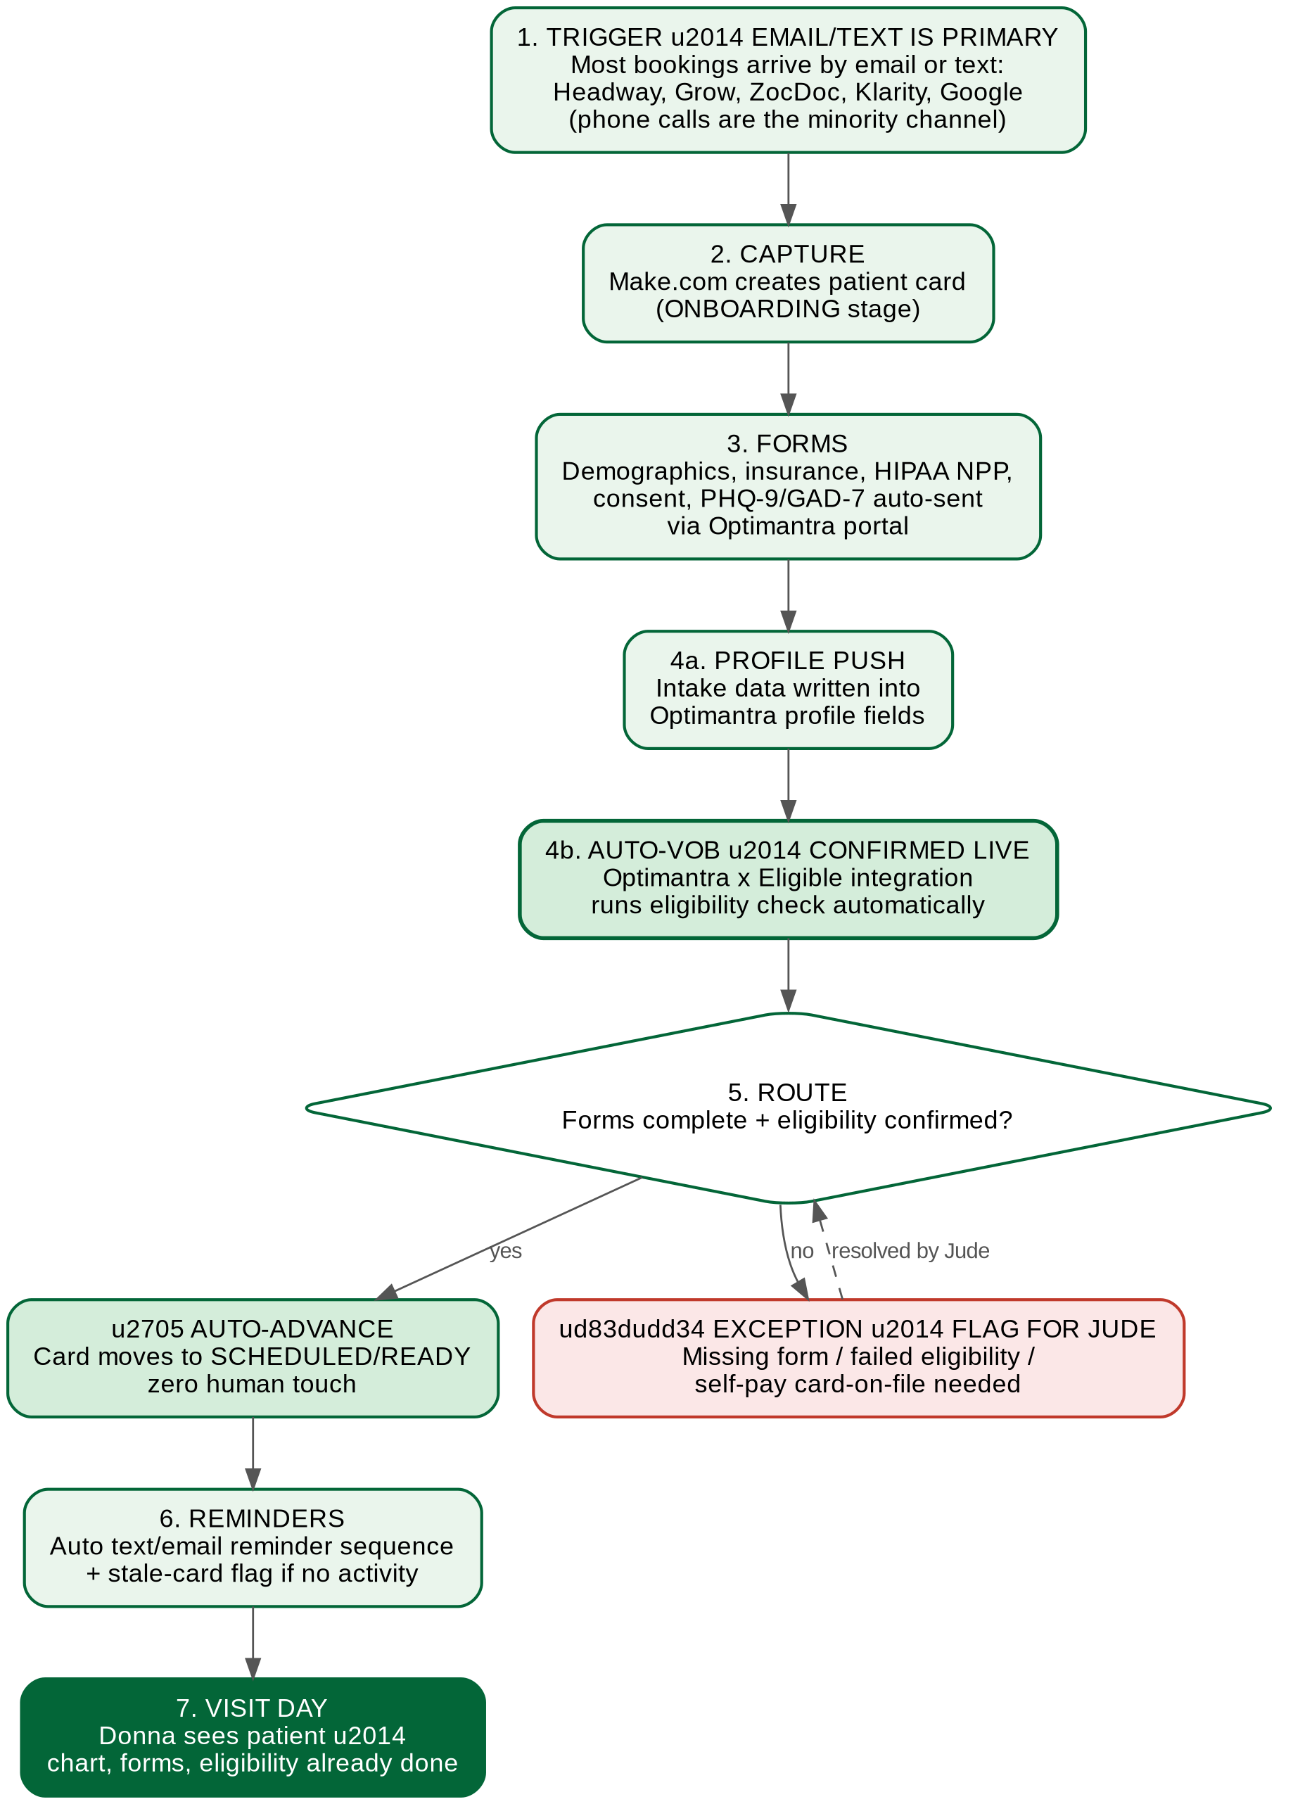
Figure 1 — Target intake automation flow, steps 1–7 above

3. Intake Capture — Email & Text Notifications (Primary Path)
Build priority
This is the highest-volume trigger and should be built first. The majority of new-patient notifications arrive as email or text messages from Headway, Grow Therapy, ZocDoc, Klarity, and Google — not as phone calls. Phone-call intake (Section 7) is a real but secondary channel and should be sequenced after this one, not before it.

3.1 What to build
A Make.com scenario that watches (a) the practice's booking-confirmation inbox for new-booking emails, and (b) the business text/SMS line for booking notifications, parses new-booking notifications from Headway, Grow Therapy, ZocDoc, Klarity, and Google, and creates a new patient card in ClickUp / the Care Pipeline board.

3.2 Notes for the build
- Each booking platform formats its confirmation emails and texts differently — the parsing logic needs a separate template/rule per platform and per channel (email vs. SMS), not one generic parser.
- Where a platform offers a native webhook or API instead of email/text parsing, prefer that — it's more reliable and should be the first option evaluated per platform.
- Confirm which of Headway, Grow Therapy, ZocDoc, Klarity, and Google notify by email vs. text vs. both — this determines whether the Make.com scenario needs one intake channel or two per platform.
- This scenario should run independently of the Care Pipeline portal's live backend — it does not need to wait on that build to go live.
- Output of this step: a new card with patient name, DOB, contact info, insurance info (if provided at booking), appointment date/time, and source platform tagged.

4. Automated Verification of Benefits (VOB)
Status: Confirmed available
Optimantra already has an active integration with Eligible (a benefits-verification vendor connected to 1,900+ payers) on this account. This does not require a new vendor relationship — it needs to be wired into the automated intake flow.

4.1 What to build
- Map the intake-captured insurance fields (member ID, payer name, group number, subscriber DOB) to the exact Optimantra profile fields Eligible reads from.
- Confirm with Optimantra support whether Eligible auto-triggers the moment those fields are saved to a profile, or requires a manual ‘run eligibility’ action even with the integration active. This determines whether the flow is fully hands-off or needs one click per patient — get this in writing from Optimantra support before building the trigger logic.
- Write eligibility results (coverage status, copay, deductible) back into the patient card so Jude/Donna see it without opening the chart separately.
Known limitation to build around
Automated eligibility checks (270/271 transactions) reliably confirm active coverage and copay/deductible, but for behavioral health specifically, some payers don't return full benefit detail — session limits, prior-authorization requirements — through the automated feed. Build the exception path (Section 6) to route these cases to Jude for a manual call rather than assuming every check is complete.

5. What Make.com Is (for anyone on the build unfamiliar with it)
Make.com is a no-code/low-code automation platform — think of it as connective tissue between apps that don't otherwise talk to each other, without writing a full custom backend for each connection.

5.1 Core concepts
- Scenario — a single automated workflow (e.g., “new booking email arrives → create ClickUp card → send Optimantra intake forms”).
- Trigger — the event that starts a scenario: a new email arriving, a webhook being hit, a scheduled time interval, a new row in a spreadsheet, etc.
- Module — each step inside a scenario. Modules connect to specific apps (Gmail, ClickUp, Optimantra via API/webhook, Twilio, etc.) and perform one action each: read data, transform it, write it somewhere else.
- Webhook — a URL that an external system can call to push data into a Make.com scenario instantly, instead of Make.com having to poll/check periodically. Preferred over email-parsing wherever a platform supports it.
- Router / Filter — logic inside a scenario that sends data down different paths depending on conditions (e.g., “if eligibility check fails, route to Jude; if it passes, auto-advance the card”).

5.2 Why it's the right tool here
It avoids building and hosting custom middleware for every integration (Optimantra ↔ ClickUp ↔ booking platforms ↔ SMS/email). Most of the connections needed for this build (email, webhooks, ClickUp, SMS/email sending) have pre-built Make.com modules, which shortens build time versus writing bespoke API integration code for each one.

5.3 What the developer needs access to
- An ECH Make.com account (owner: Donna) with the developer added as a collaborator.
- Optimantra API/webhook credentials — request from Optimantra support, scoped to what this build needs (profile read/write, eligibility trigger if applicable).
- ClickUp API token for the relevant workspace/board.
- Access to the booking-confirmation inbox (or a dedicated intake-only inbox, which is cleaner and recommended over using a personal inbox).

6. Exception Routing
The entire point of this build is that Jude's queue should only ever contain things that actually need a human. Build the routing logic so the following — and only the following — create a task/flag for Jude:
- An intake form wasn't completed within a defined window (e.g., 24–48 hrs pre-visit).
- Eligibility check failed, returned inactive coverage, or returned incomplete behavioral-health-specific benefit data.
- Self-pay patient needs card-on-file collection.
- A card has had no status change within a defined “stale” threshold (recommend starting at 48 hrs, adjustable).
Everything else should move through the pipeline with zero manual touch.

7. Phone-Call Intake — Two Build Paths
Optimantra itself does not have a built-in phone/receptionist system — it's an EHR, not a phone system. Getting phone-call intake into this same pipeline means either (A) using a third-party AI-receptionist vendor that connects to Optimantra, or (B) building a custom voice-intake layer in-house. Both are laid out below for the developer to scope against.

Option A — Third-party AI receptionist vendor
Example: Cevi.ai — a third-party automation platform built specifically to connect to Optimantra, offering an AI voice receptionist (answers calls, captures intake conversationally, pushes data into Optimantra) plus a pre-built insurance-verification workflow. This is one example vendor found via research, not a vetted recommendation — evaluate against comparable vendors before committing.

Option B — Custom-built voice intake
Components required if building in-house:
- Telephony layer to receive calls and provide a business number (e.g., Twilio).
- Conversational AI layer to understand the caller and run the intake question script.
- Integration logic writing captured call data into Optimantra via API — this overlaps with work already planned for the Care Pipeline build.
- End-to-end HIPAA compliance: BAA-covered telephony/AI vendor, encrypted call handling and storage — same requirement already covered by the developer's existing BAA with ECH, but any new sub-vendor (telephony, voice AI) needs its own BAA.
 | Option A — Vendor | Option B — Custom build
Cost | Recurring subscription, lower upfront | Larger upfront dev cost, no per-workflow fee
Timeline | Faster to live | Longer — building what vendors already sell
Customization | Limited to vendor's templates | Full control over psych-specific intake script
Who owns it if it breaks | Vendor's responsibility | ECH/developer responsibility
Recommendation for the developer
Scope Option B's time/cost estimate and provide it alongside a quick evaluation of Option A, so Donna can compare a real build quote against a vendor subscription before deciding. Given the developer is already mid-build on the Care Pipeline portal with existing Optimantra API familiarity, folding this in may be efficient — but it is a meaningful scope addition, not a small add-on, and should be quoted as such.

8. Website Lead Capture — Chatbot with Live Handoff
Currently the website update/lead-gen push is a future-phase item in the practice's broader growth plan, but the chatbot's capture logic should be designed now so it plugs into the same intake pipeline once the site is live — not built as a separate, disconnected system.

8.1 What to build
- A website chatbot that answers common visitor questions (services offered, insurance accepted, telehealth vs. in-office, self-pay rates) and captures lead info from visitors who show intent to book: name, contact info, reason for inquiry, and insurance type if offered.
- During business hours: a live-handoff path so the chatbot can escalate a visitor to a real person (Jude) mid-conversation if the visitor wants immediate help or the bot can't resolve the question.
- After hours: the chatbot captures the lead and sends an auto-reply confirming follow-up, then queues the lead for Jude the next business day — no visitor should be left with a dead-end conversation.
- Captured lead data should feed the same Make.com pipeline as booking-platform intake (Section 3), but routed into a LEAD stage — see Section 9 — rather than jumping straight to ONBOARDING, since a website inquiry is not yet a booked patient.
Why this matters for sequencing
This chatbot is the front door for the organic/paid lead-generation push already planned to ramp new-patient volume ahead of the incoming NP's start. Designing its data capture to plug into the same pipeline now avoids having to retrofit a disconnected lead source later.

9. Lightweight CRM for Lead Tracking
Optimantra is the EHR of record for patients already under care — it is not the right place to track people who have inquired but not yet booked or been seen. A lightweight CRM layer is needed to hold leads through that gap, so nothing generated by the chatbot, phone inquiries, or ad campaigns gets lost before it becomes a booked patient.

9.1 What to build
- A simple lead pipeline, separate from the Care Pipeline patient board, with stages such as: New Lead → Contacted → Booked → Converted to Patient → Lost/No Response.
- Each lead record should carry: source (website chatbot, phone, referral, paid ad, organic), contact info, date captured, follow-up owner, and current status.
- Given ClickUp is already in the stack, the simplest build is a second ClickUp list/board dedicated to leads, rather than introducing a new standalone CRM product — evaluate this first before recommending a dedicated CRM tool.
- Once a lead books an appointment, that record should trigger creation of the patient card in the Care Pipeline board (Sections 3–6 flow) — the lead record and the patient record should link, not duplicate data entry.

9.2 Why this matters
This is the missing piece connecting the growth plan (organic + paid leads targeting ~10 new patients/day) to the practice's broader visibility gap. Lead-to-booked conversion rate, lead source performance, and average time-to-contact are exactly the kind of numbers that belong on the company dashboard already discussed separately — this CRM layer is what would feed those metrics, rather than leads existing only in someone's inbox or memory.

10. Relationship to the Care Pipeline Portal
This intake/VOB automation does not need to wait on the Care Pipeline portal's full backend build — it can run as standalone Make.com scenarios now, using ClickUp as the interim board. When the Care Pipeline portal's live backend and webhook architecture are ready, these scenarios should be pointed at the portal instead of ClickUp, preserving the same Kanban stages (Onboarding → Reconciled), stale-card flags, and “Flag for Donna” escalation already spec'd for that build.

11. Open Questions for the Developer to Resolve
- Optimantra: does Eligible auto-trigger on profile save, or does it require a manual action even with the integration active? (Confirm directly with Optimantra support.)
- Optimantra: what is the exact scope of API/webhook access available on this account, and what does the developer need requested to get credentials?
- Per booking platform (Headway/Grow/ZocDoc/Klarity/Google): does each offer a native webhook/API, or is email/text parsing the only option? Also confirm exactly which Google product/channel is meant (e.g., Google Business Profile messages, Google Voice texts) so the right integration is built.
- Phone intake: quote Option B (custom build) time/cost, and provide a short evaluation of Option A (vendor) as a comparison point.
- What threshold should define a “stale card” — is 48 hours the right default, or should this vary by booking source?
- Chatbot: confirm which website platform/builder will be used once the site update happens, and whether the chosen chatbot tool has a native Make.com connector or needs custom webhook work.
- Chatbot: define exact business-hours vs. after-hours behavior (hours, which staff member is “live,” and what the bot says when no one is available) — needs Donna's sign-off, not a default assumption.
- CRM: confirm whether a second ClickUp list is sufficient at current lead volume, or whether a dedicated CRM tool should be evaluated — revisit once real lead volume from the chatbot/growth push is known.

12. Suggested Build Sequence
- Booking-platform intake capture (Section 3) — standalone, no dependencies.
- Auto-send intake forms via Optimantra portal, triggered on card creation.
- Profile field mapping + VOB automation (Section 4) — pending the Optimantra auto-trigger confirmation.
- Exception routing logic (Section 6).
- Appointment reminder sequence + stale-card flagging.
- Lightweight CRM / lead pipeline (Section 9) — can be built in parallel with the above, since it's a separate board from the patient pipeline.
- Phone-call intake (Section 7) — sequenced after the above, pending the Option A vs. B decision.
- Website chatbot (Section 8) — sequenced last, dependent on the website rebuild itself, which is a separate future-phase project.

13. Brand Guidelines for Development
Reference this section for anything patient-facing built as part of this project (chatbot widget, confirmation emails/texts, website booking forms, any UI the developer touches).

13.1 Logo

- A transparent-background copy of this logo file is attached alongside this document — use that file directly rather than re-exporting from this PDF/Word doc.
- The logo should be reproduced in full, exactly as shown — no color variations, reversals, crops, or distortions.
- On dark backgrounds, use the white/light version of the logo only (request from Donna if not already provided) — do not place the full-color version on a dark background.
- The logomark (tree/figure icon) should not be used alone separated from the wordmark in official materials — use the horizontal or vertical lockup.

13.2 Brand Colors
Swatch | Name | Hex | Use
 | Primary — Dark Green | #036638 | Headers, primary buttons/accents, main brand color
 | Secondary — Light Green | #65BD6C | Secondary accents, highlights
 | Accent — Banana Mania | #FBE7B2 | Sparing accent use only
 | Accent — Sage | #EADEC0 | Sparing accent use only

13.3 Typography
- Primary typeface: Gilroy — used for headers/large text.
- Secondary typeface: Inherit — used for body text pairing with Gilroy.
- If either font isn't practical for a given build context (e.g., email clients with limited font support), confirm a fallback with Donna rather than defaulting silently.

14. Contact
Extracting the logo from this file
The full-resolution logo asset below is embedded at its original resolution. In Word, right-click the image and choose “Save as Picture…” to extract it as a standalone PNG — useful if this document ends up being the only file that gets forwarded.


